[Best IPOs and Worst IPOs - 2024 (trendlyne.com)](https://trendlyne.com/ipo/screener/year-2024/)

Hedge means protection

Why to invest-> Hedge against Inflation

Inflation means Value of money going down and same goods&services going up.

When RBI lower its interest rates ,it gives capacity to people to buy more .People can borrow nad buy. Example in Covid.results in increase in inflation

When RBI INCREASE interest rates , people do not have capacity to buy more

Types of investing ->Intraday Buy and sell on same day

* Swing Trading holding for few weeks
* Positional Trading

The Simplest form of exiting is following 200 day moving average.

If a stock is moving below 200 day moving average ,then the stocks shows sign of weakness.

For analysis we see CNX500 NIFTY 500

200 MA works as the best support zone

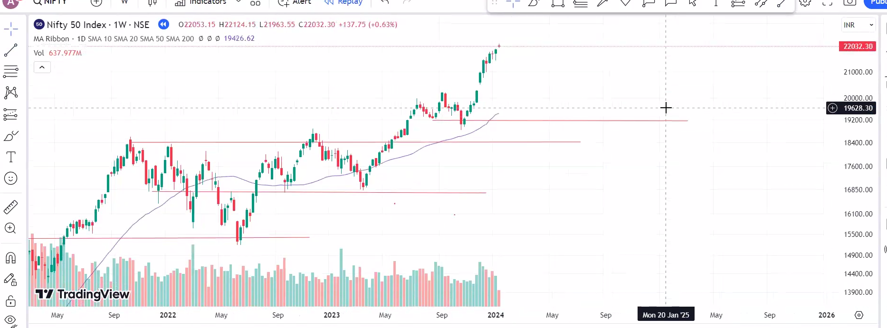

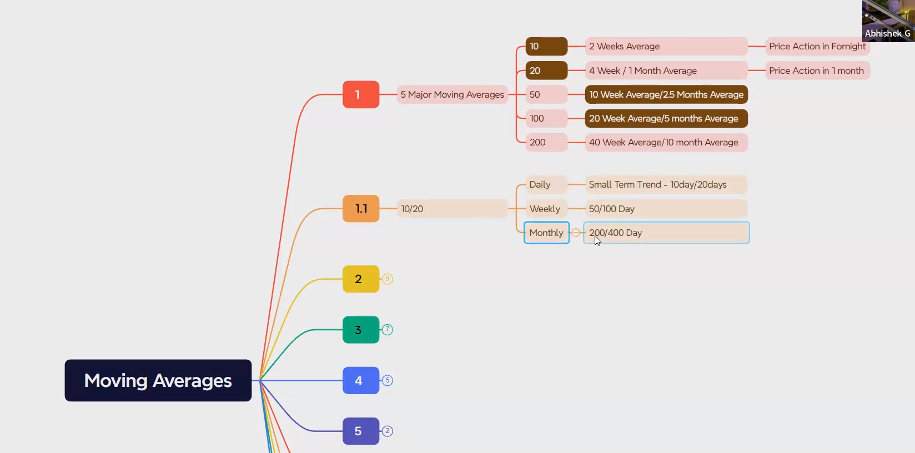

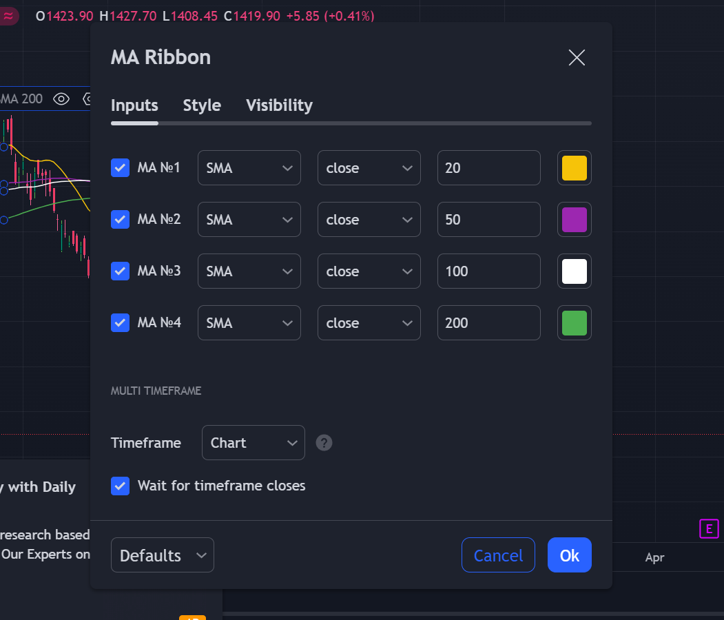

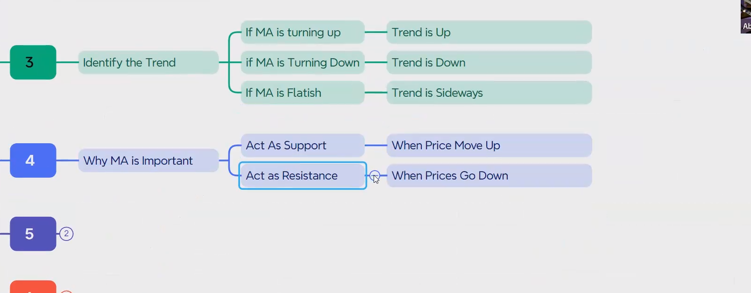





**

‘’

If candles goes far from 10 days moving average then it will definitelyt come down down and touch the 10 days MA



First change will appear in days then months and then 200 days MV.